

Inner Air

**USER DOCUMENTATION**

Jade Oakes, Data Science, Project Manager

Andrew Bader, Computer Programming and Development, Developer

Christian Baier, Computer Programming and Development, Backend

Jose Chavez, Computer Programming and Development, Full Stack

Karina Osmanova, Computer Programming and Development, Frontend

Instructor: Susan Rizzo

Industry Mentor:

Marcella Rossi – Wake Technical Community College

May 03, 2023

Programming & Information Sciences Department

Information Technology Division

Wake Technical Community College, Raleigh, NC 27709

Product: Documentation

This document is created for product users and covers both End-users and Administrative users.

Hardware requirements: Desktop, laptop, tablet, or mobile device

Software requirements: Windows, MacOS, or Linux

1. System Administrator Documentation

The application will be containerized before deployment. The required prerequisites will be automatically installed before the application runs. For any maintenance that will need to be performed we will be able to provide a new container that can be pulled and run.

Alternatively, the application can be used –as is – and can be “installed” and “updated” via git pulls to the production branch for this application. The setup will be completed by following the steps in the readme.md file included in GitHub.

* 1. Editing user information

An admin can edit users by selecting the edit button to the left of the record on the “Admin” page.

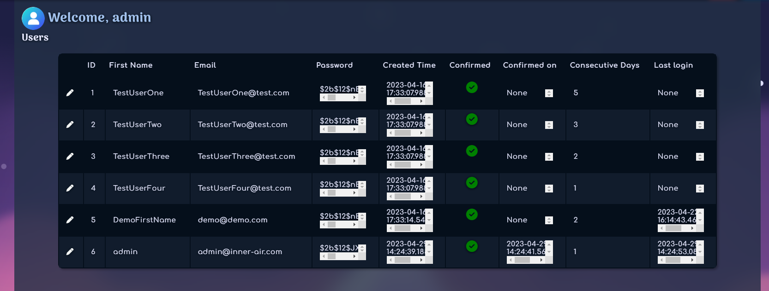

Alternatively, if needed, they can edit the information directly in the database, although this should not be necessary.

1. End-User Documentation

When accessing our site, you will start on the home page which has information on what the site provides. To access all the features of our site you will need to create an account with your name and email address and verify your email address. After verification and logging in you will land on your profile page. To get started select the EXERCISES tab at the top of the screen in the navigation bar. After selecting the tab, you will be able to choose from a list of breathing exercises with step-by-step instructions to assist you in the proper execution of the techniques.   
 After you select and complete your first exercise return to the PROFILE tab to see that your exercise has been added to your exercises completed graph. The more you complete the more you’ll be able to track your improvement in lung capacity. In addition to tracking your exercises, if you look to the top right if the page where there was a sign in button it will be replaced by a SETTINGS button. If you select this button, you will find a page where you can upload a profile picture (JPG or PNG file extensions are supported), update your email address or name, and update your password. Finally, on this page you will find a toggle button that is called ‘Anonymous Mode’. This button will decide if you want your metrics to be saved onto the global leaderboard and can be changed at any time. (NOTE: by default, anonymous mode is OFF.) Lastly, when you are finished with your exercises be sure to log out using the LOGOUT button located at the top right of the screen. Thank you for using Inner Air: your personal breathing assistant.

* 1. Creating an account

Click **SIGN UP** in the upper right-hand corner

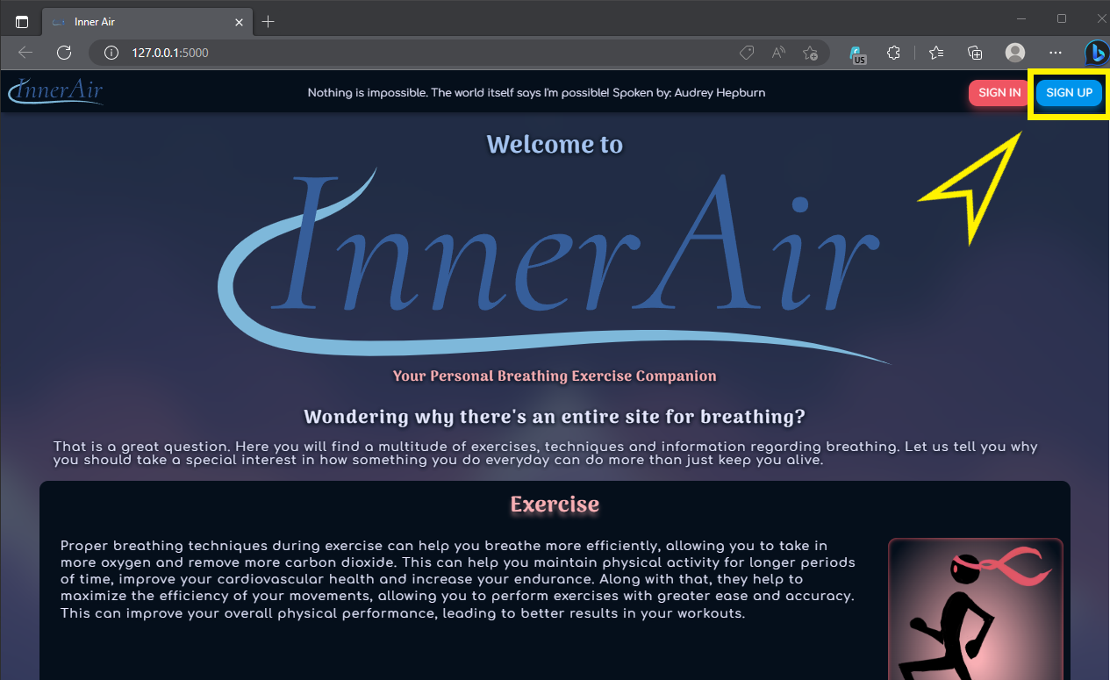

Enter your first name, email, and create a password

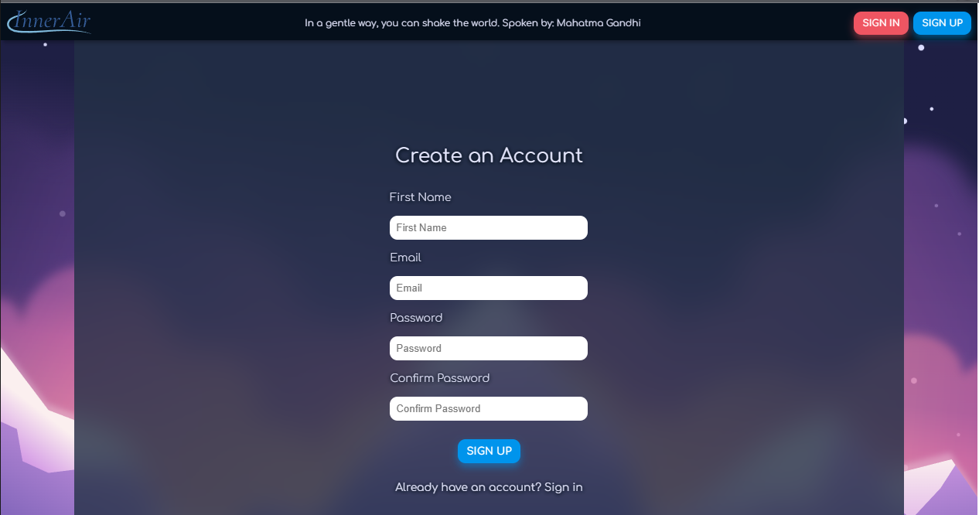

*NOTE Passwords must match and meet complexity standards*

Click **SIGN UP**

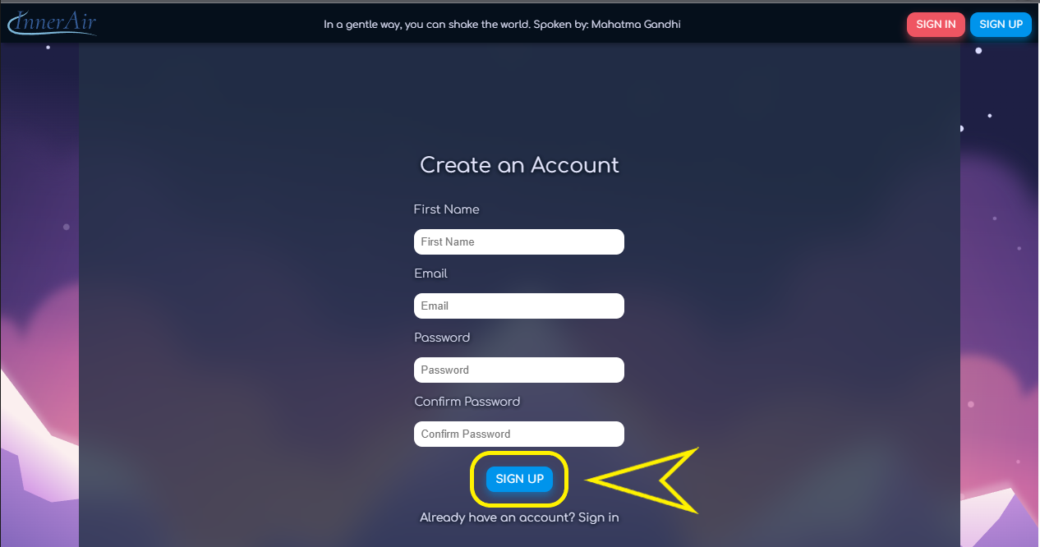

* 1. Verifying your email

Check your email and click the link to verify your email. When checking your email don’t forget to check your spam/junk folder. The email you will receive will be sent from [c626521@gmail.com](mailto:c626521@gmail.com).

You will be redirected to the Inner Air homepage

* 1. Signing in

Click **SIGN IN** in the upper right-hand corner

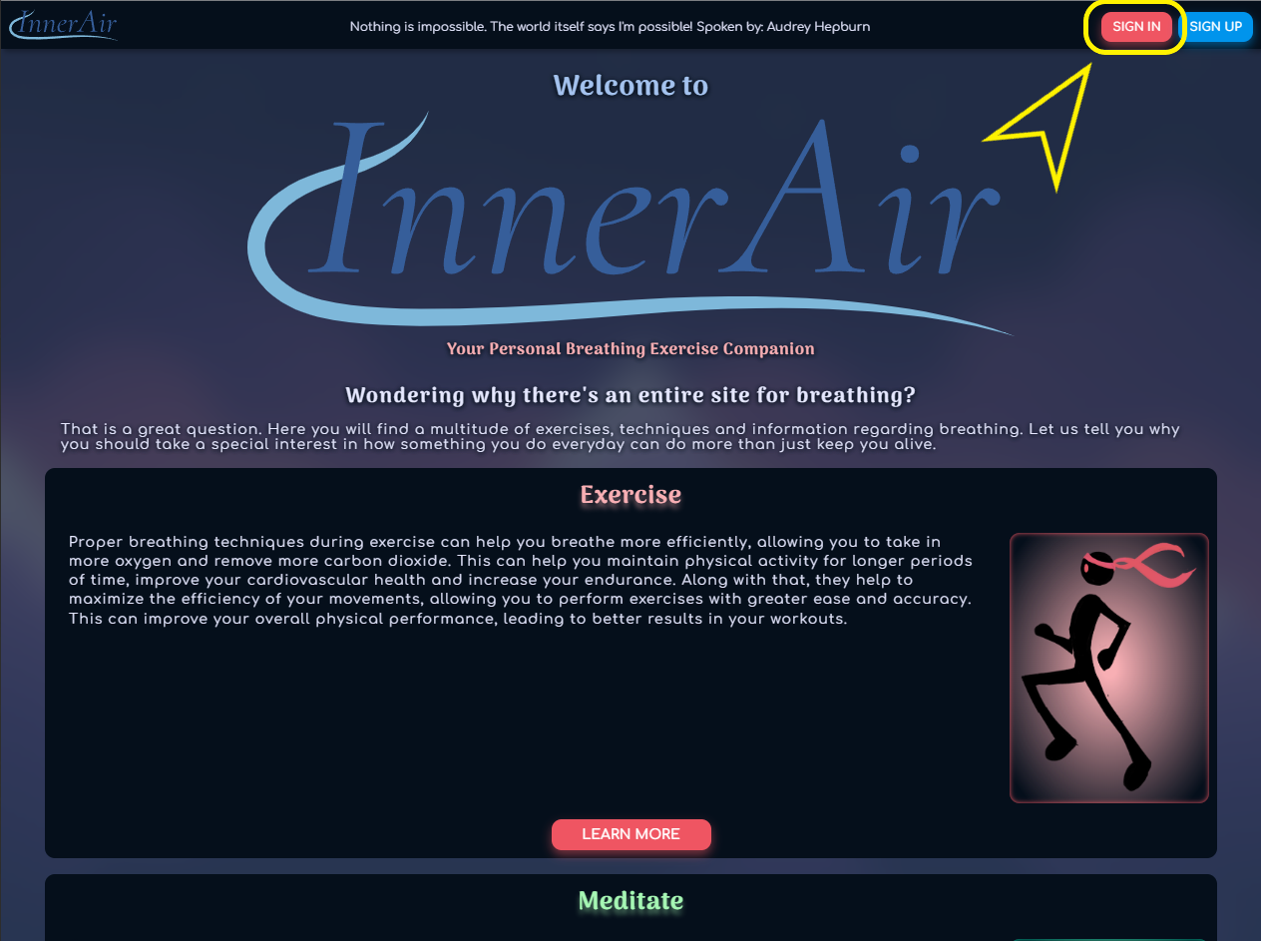

Enter the email and password you created during sign up

Click **LOGIN**

* 1. Forgot your password

On the **Sign in** page, click **Forgot password?**

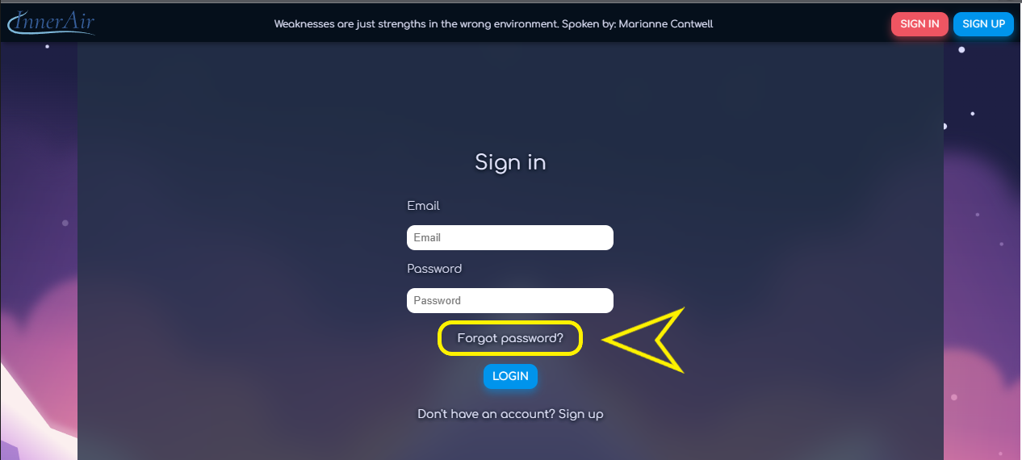

Enter your email

**REQUEST PASSWORD RESET**

Check your email for a link. Remember that the password recovery email may be in your spam/junk folder and will come from the same email as your verification email came from: ([c626521@gmail.com](mailto:c626521@gmail.com) or the email in the .env file)

Click the link to be redirected to the **Forgot Your Password?** Page

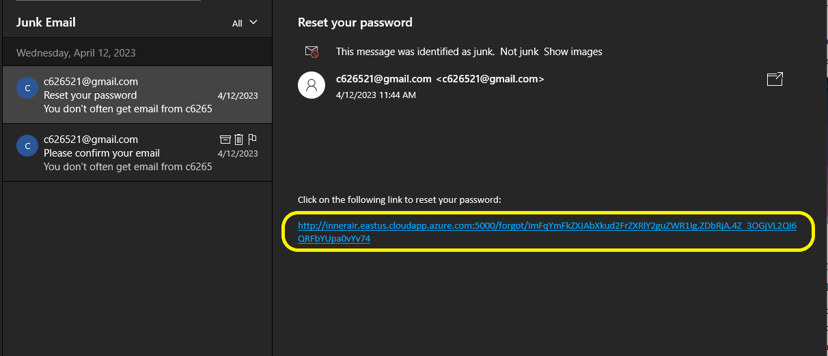

Enter a new password and confirm it

Click **RESET PASSWORD**

You can now sign in with your new password

* 1. Uploading a profile picture

Click **SETTINGS** in the upper right-hand corner

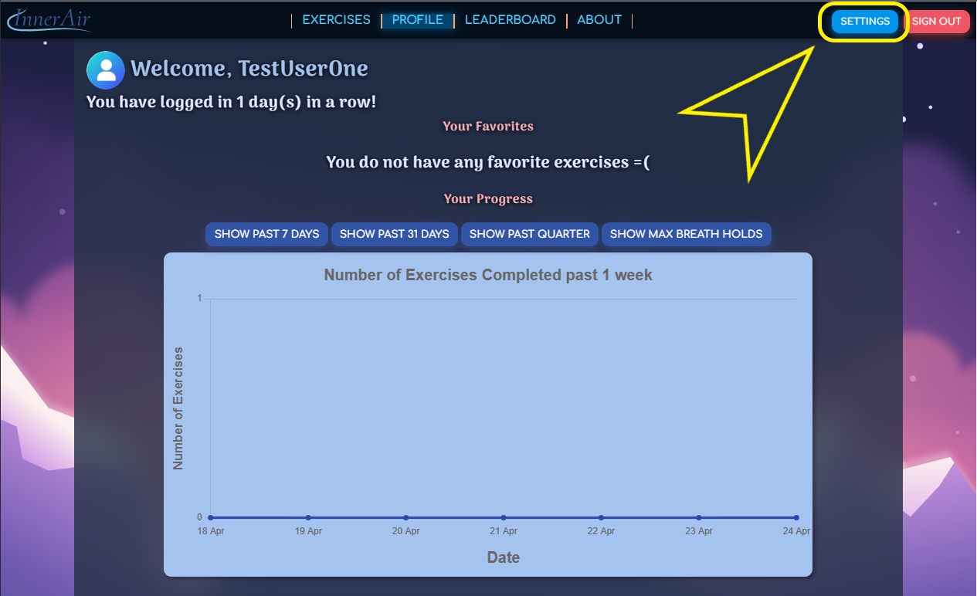

Click **Edit** under the profile picture circle

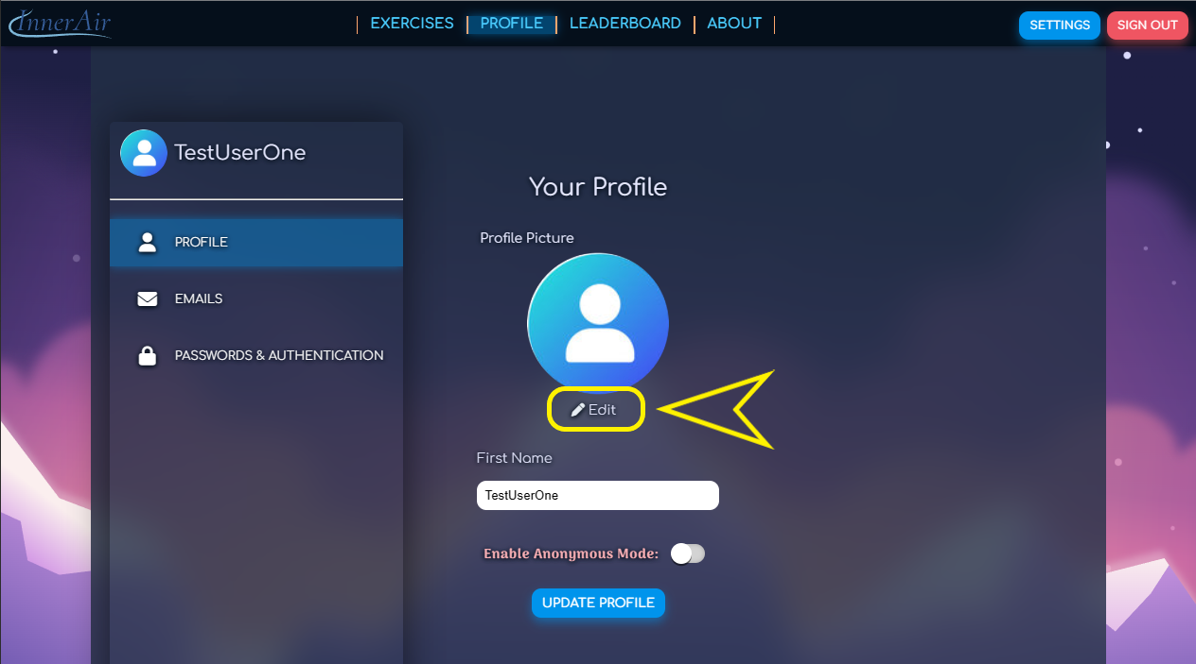

Select an image from the file explorer view

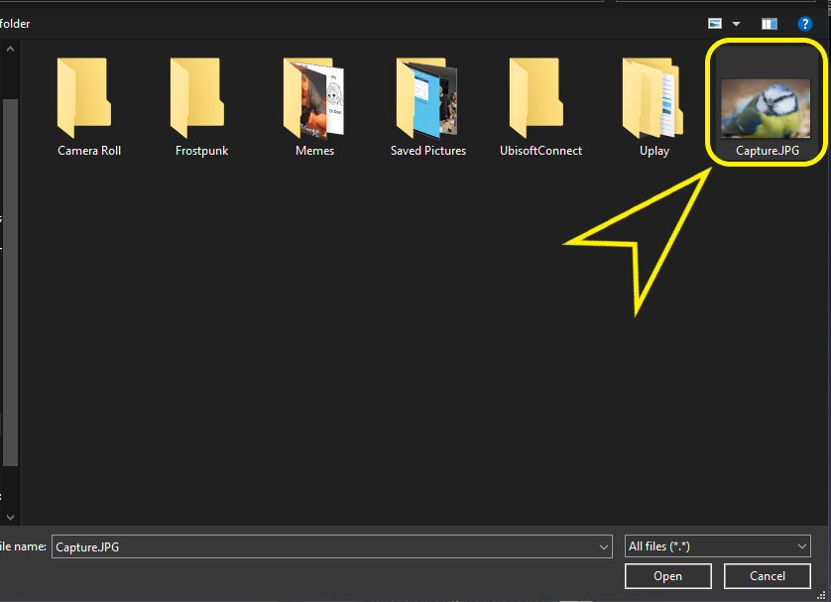

Click **UPDATE PROFILE**

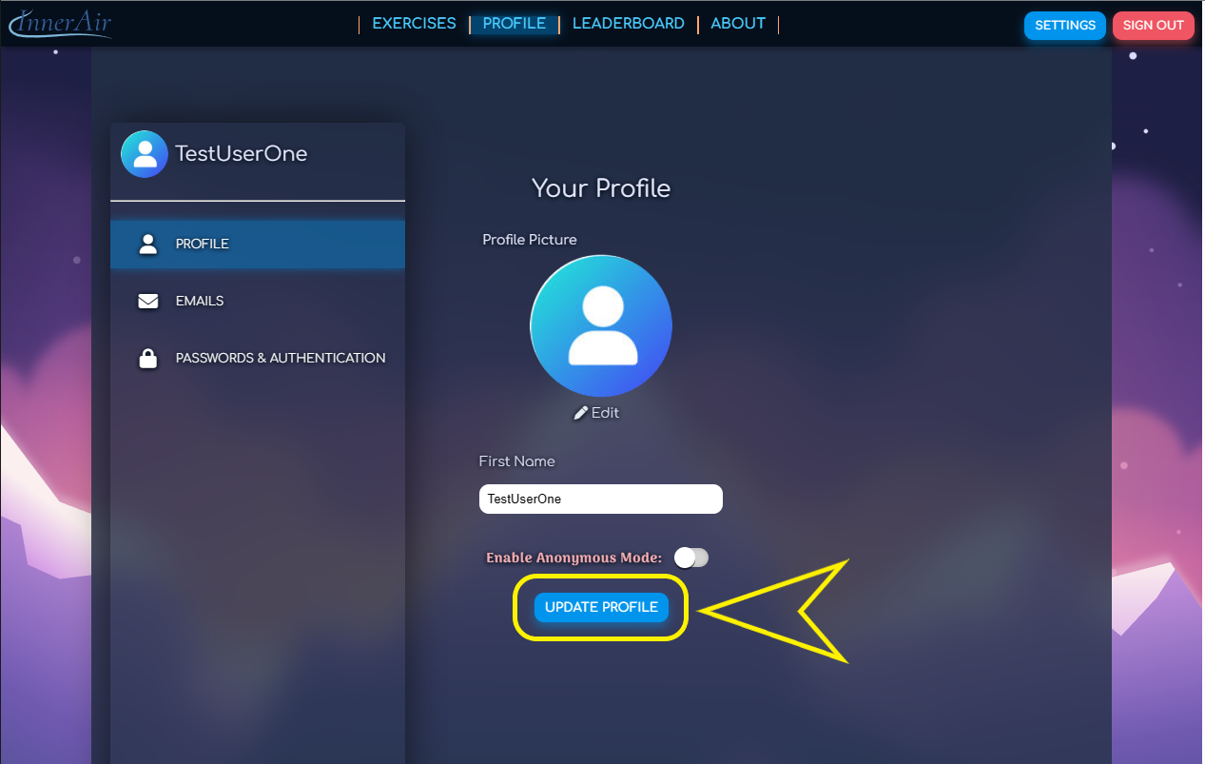

Your profile picture will have been updated.

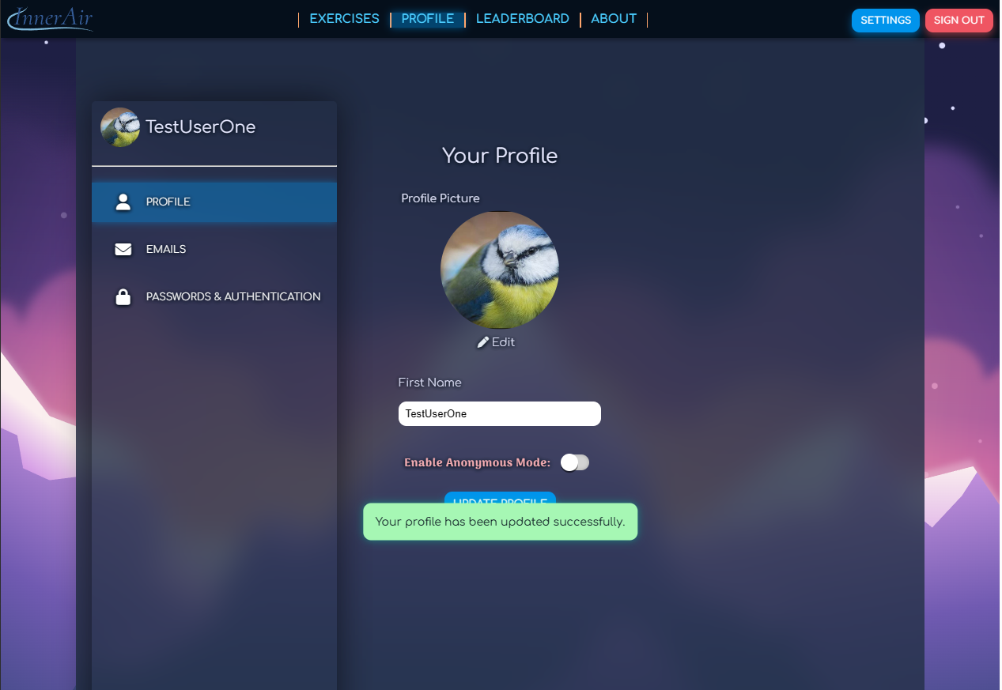

* 1. Changing your name

Click **SETTINGS** in the upper right-hand corner



Edit your name in the text area

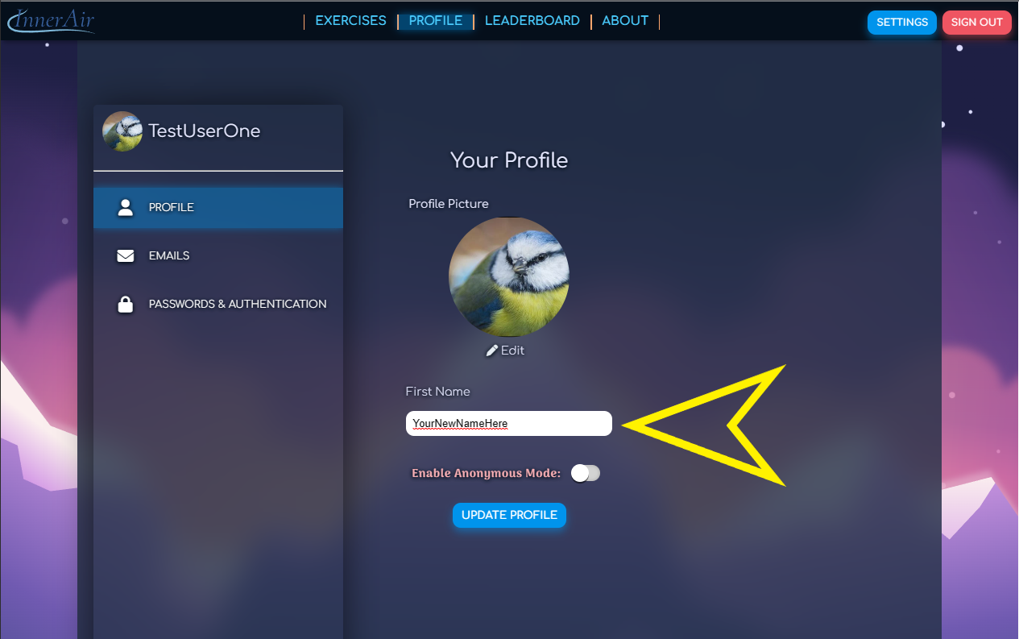

Click **UPDATE PROFILE**

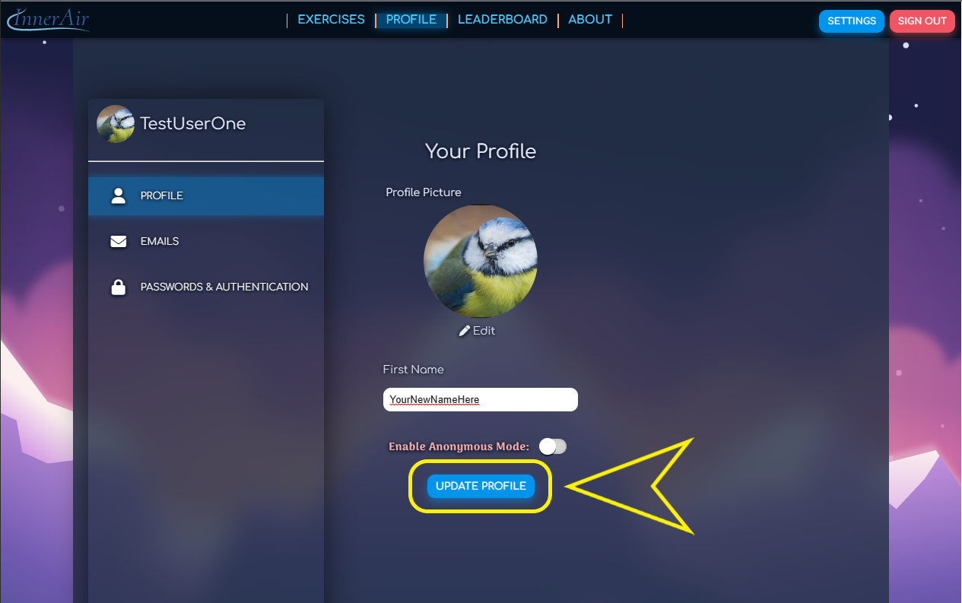

Your new name will now be applied to your profile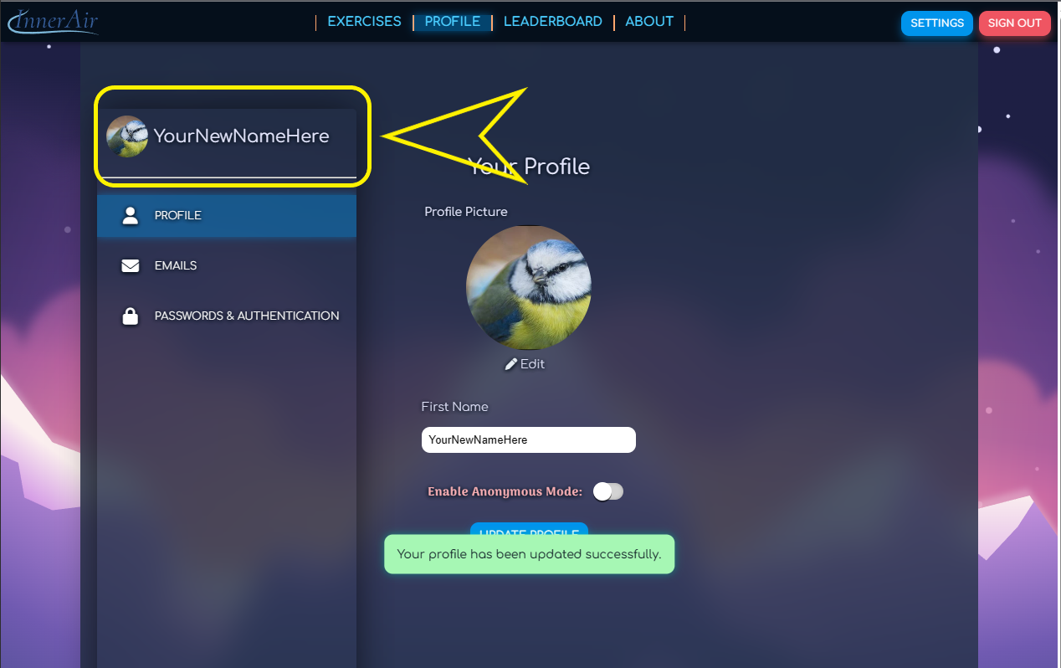

* 1. Changing your email

Click **SETTINGS** in the upper right-hand corner

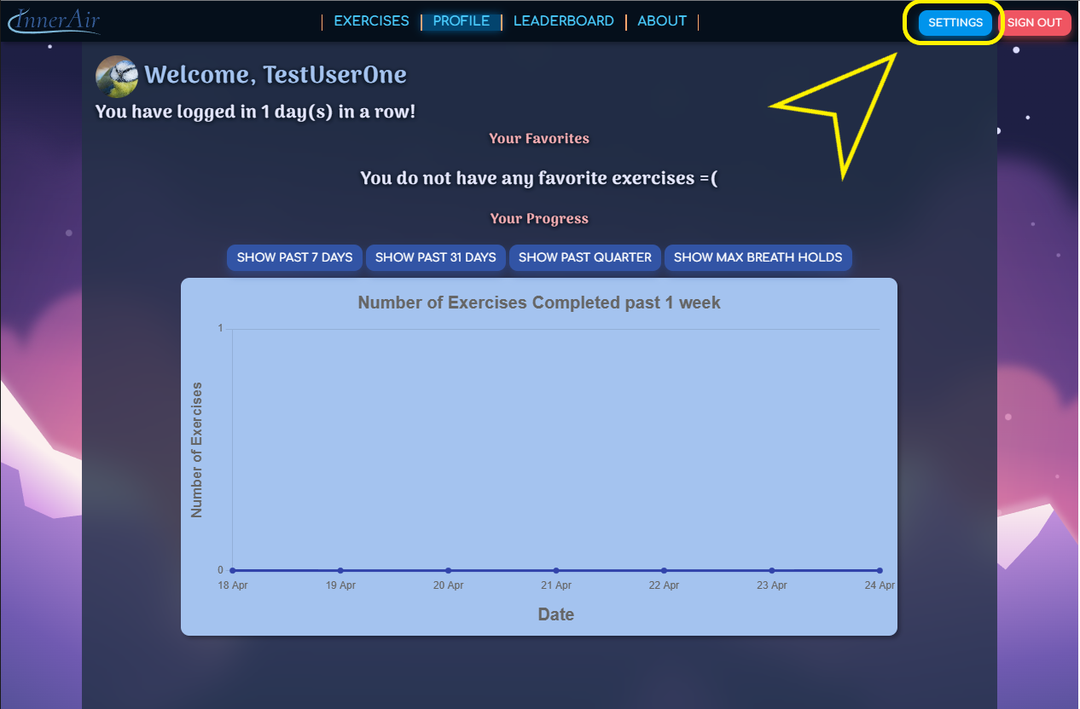

Click the **EMAILS** tab in the left navigation bar

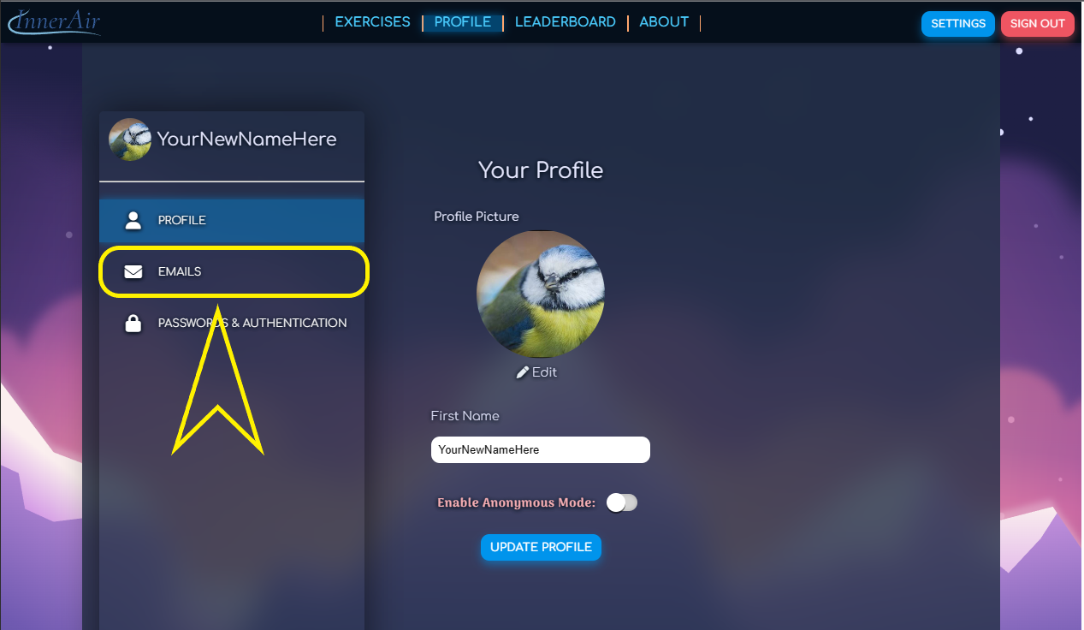

Enter your new Email.

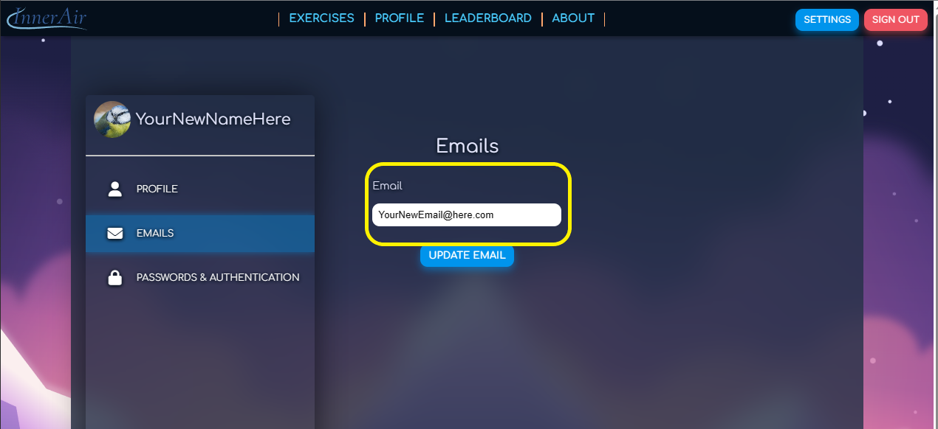

Click update email to update your email.

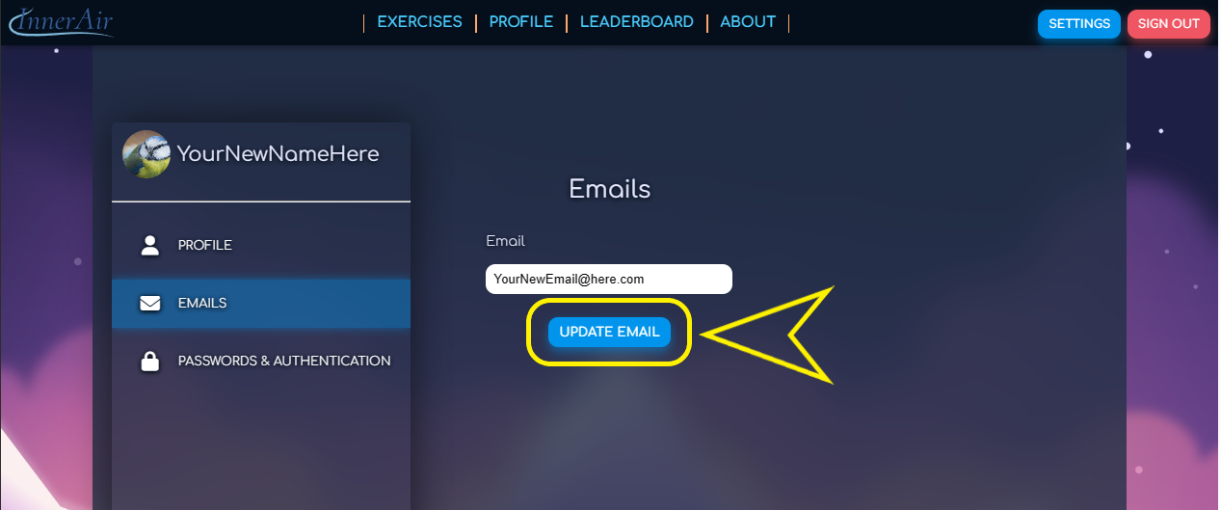

* 1. Changing your password

Click **SETTINGS** in the upper right-hand corner



Click the **PASSWORDS & AUTHENTICATION** tab in the left navigation ba

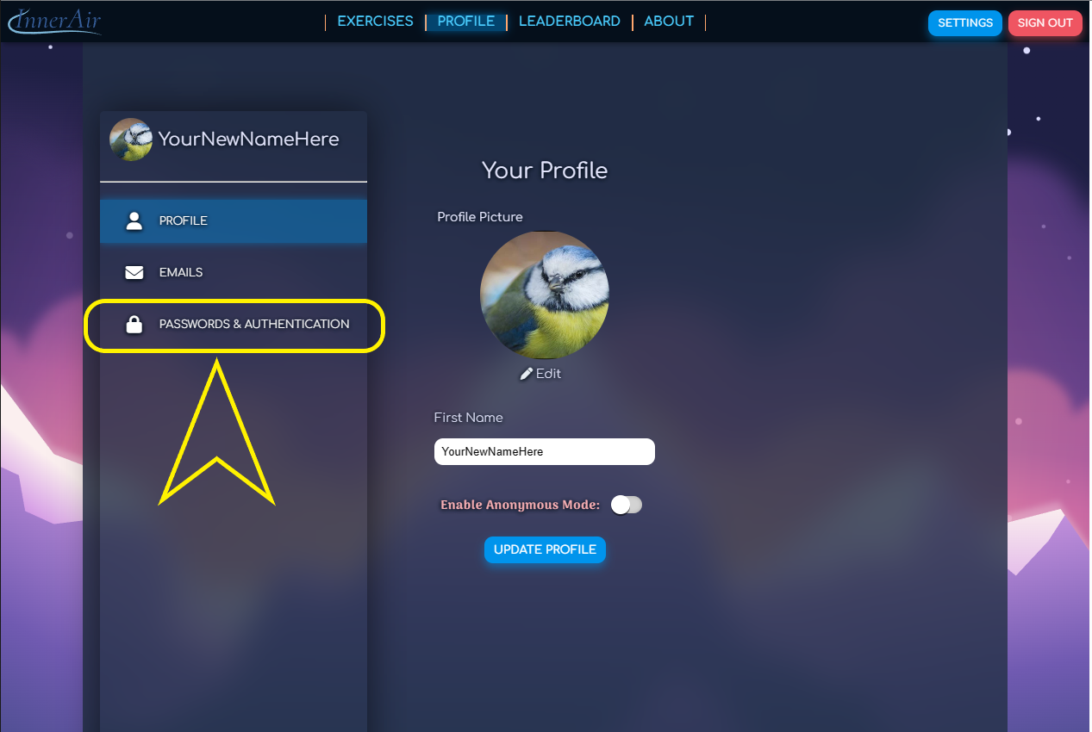

Create a new password

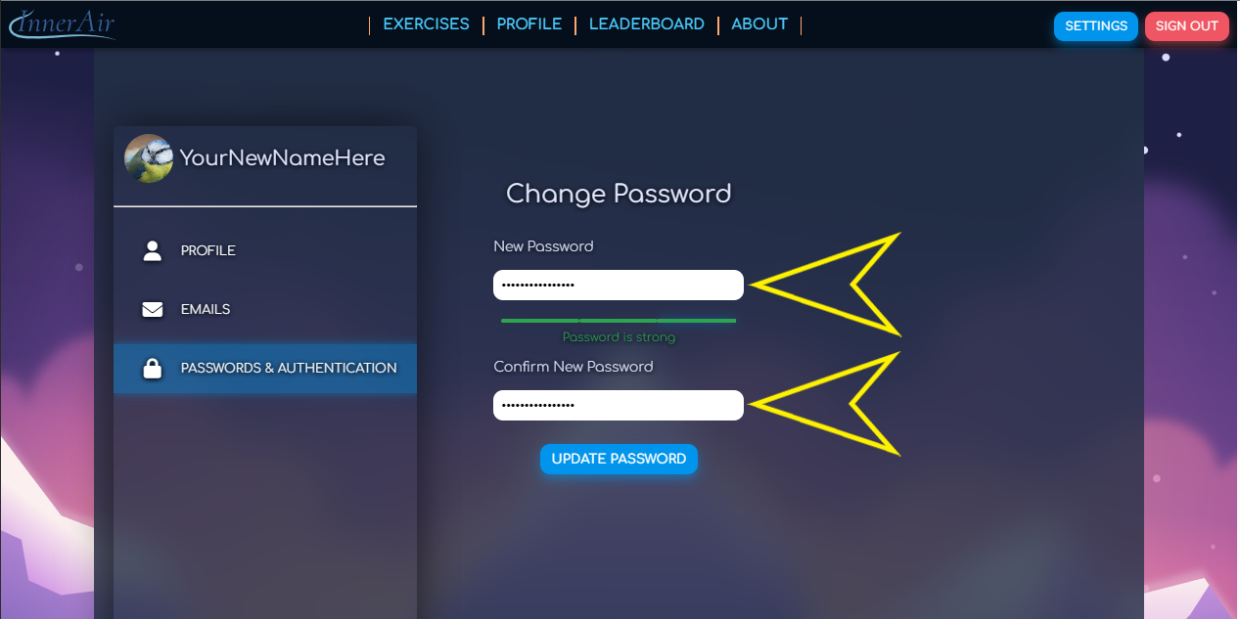

Click **UPDATE PASSWORD**

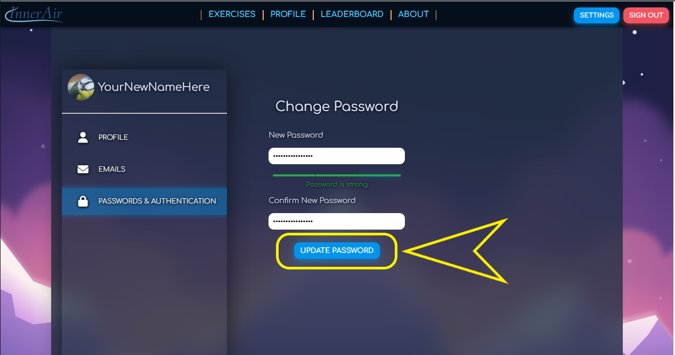

* 1. Completing an exercise

Click the **EXERCISES** tab at the top of the page

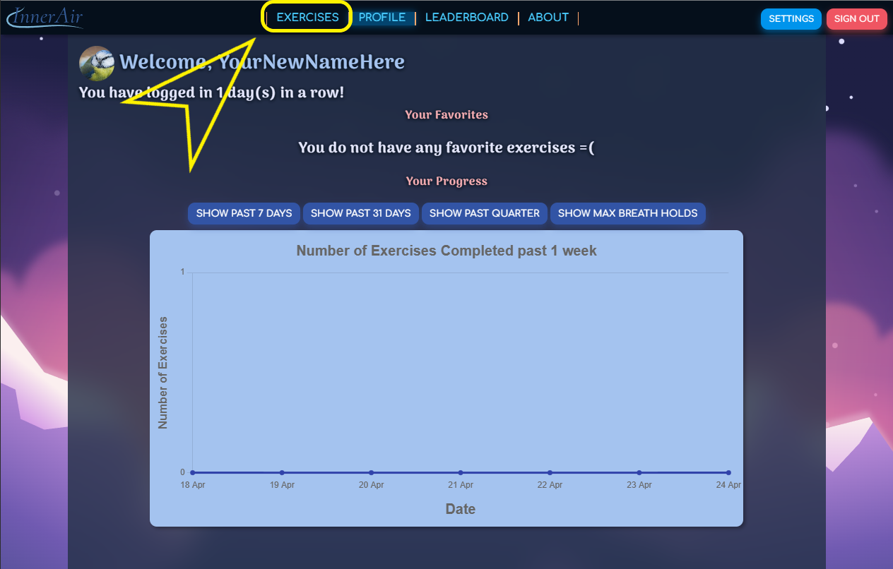

You will be brought to the **EXERCISES** tab.

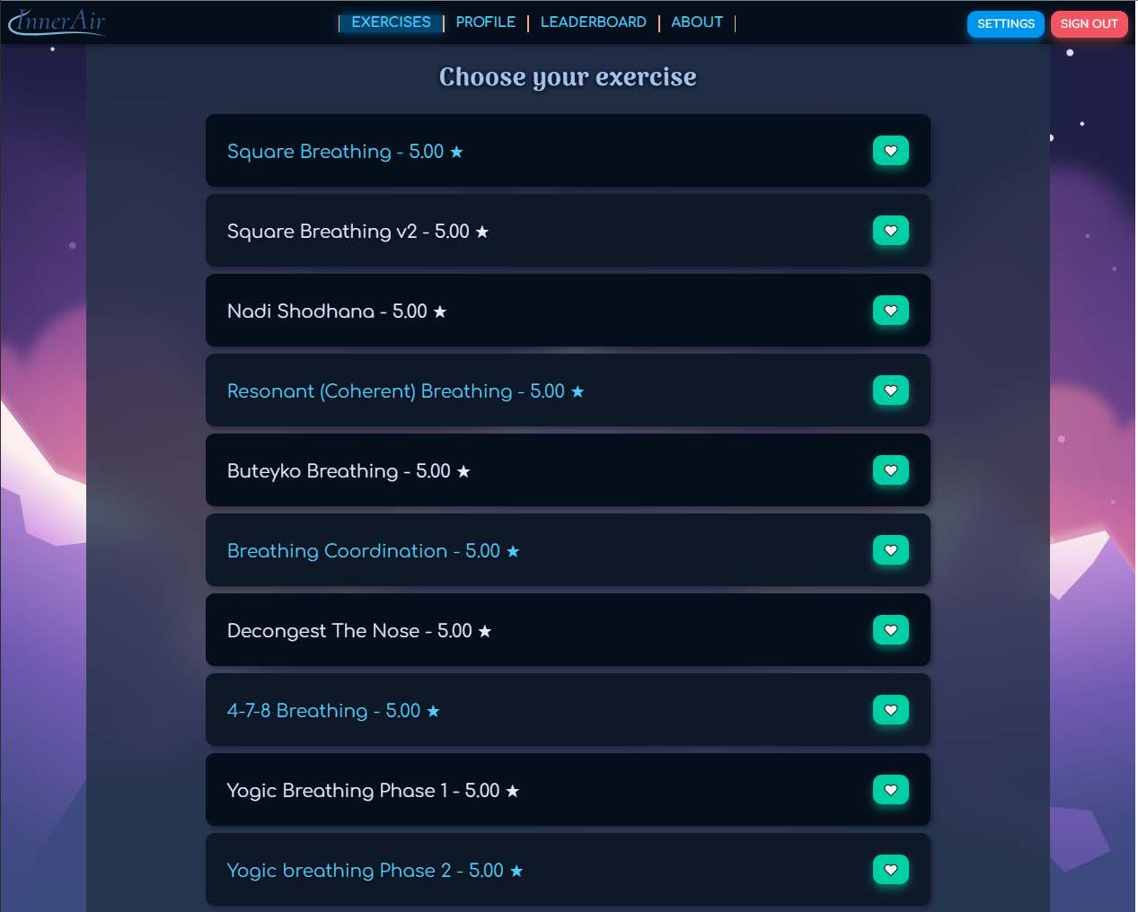

Click inside the boxes to expand them and view a description of each exercise

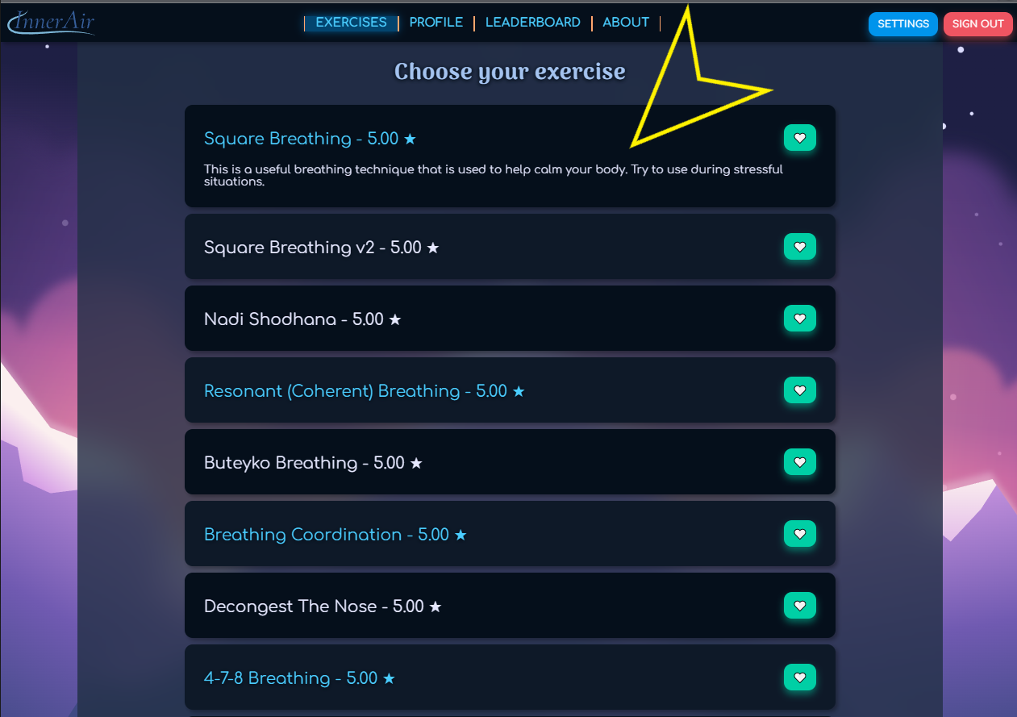

Click the exercise name to view the page for that exercise

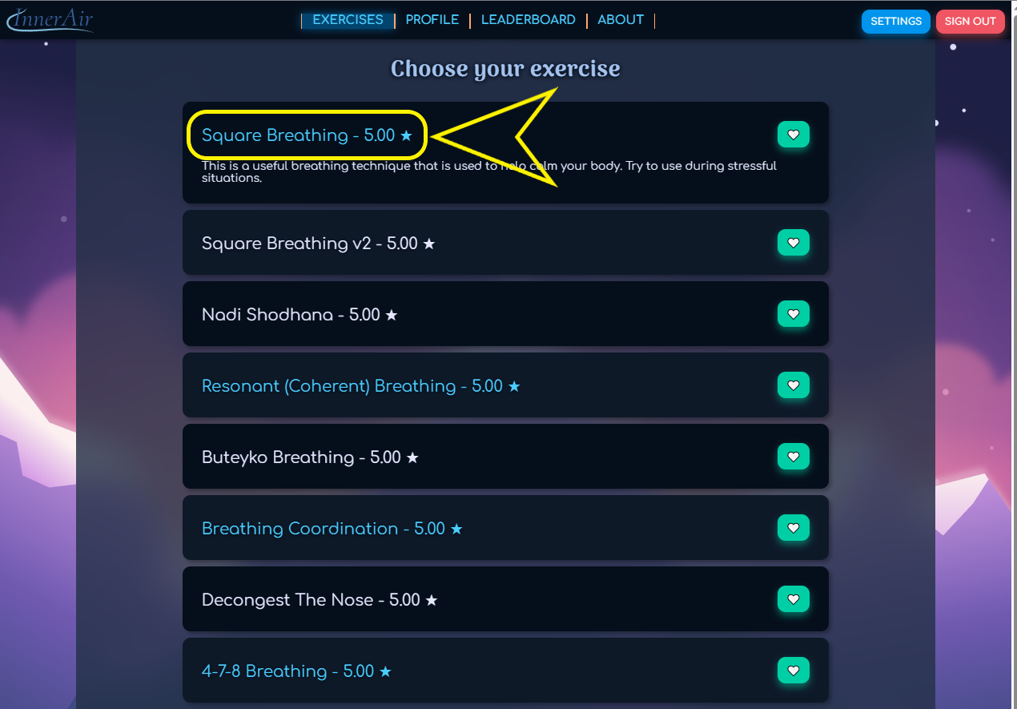

After selecting your exercise, you will be brought to that exercise.

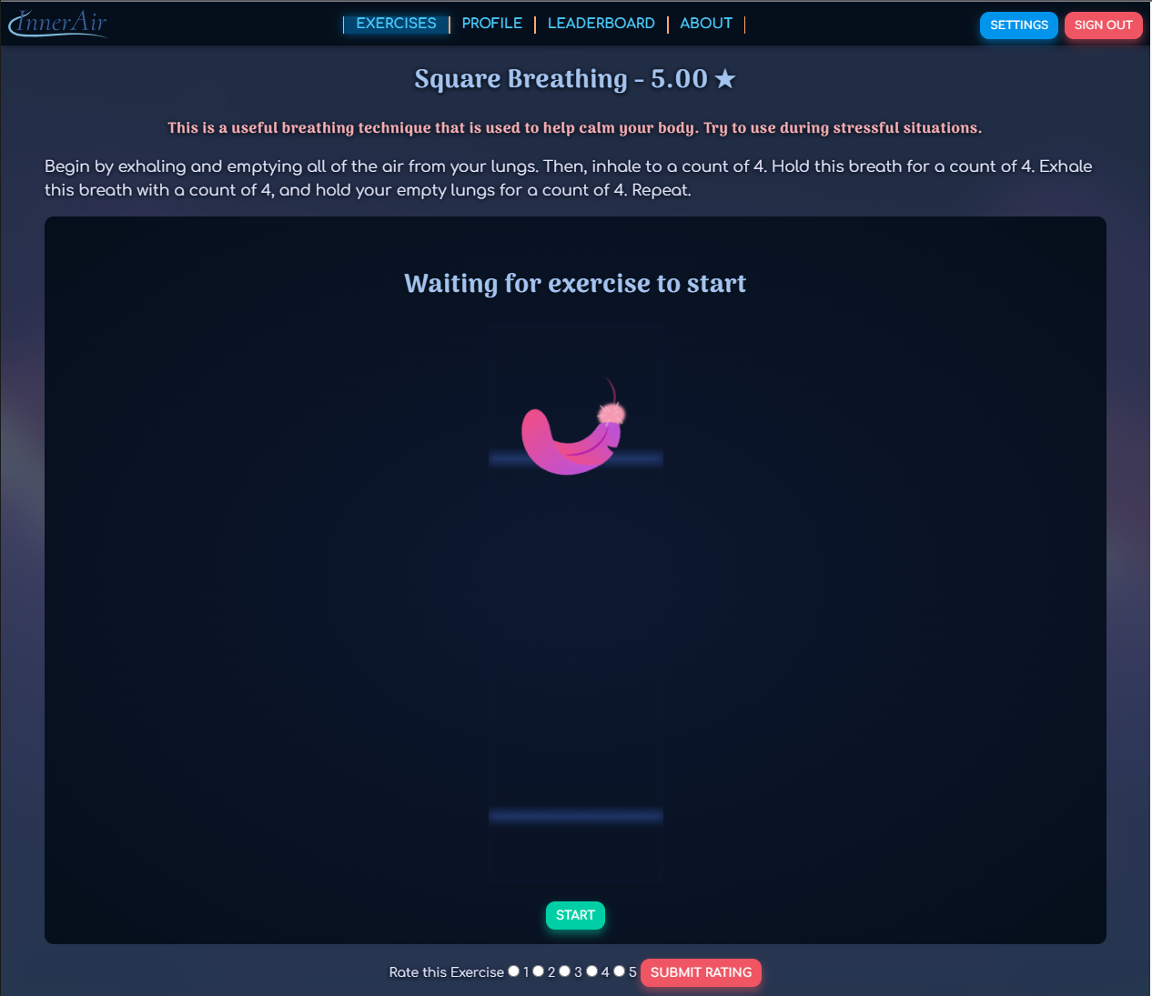

Click **START** at the bottom of the page to begin the exercise

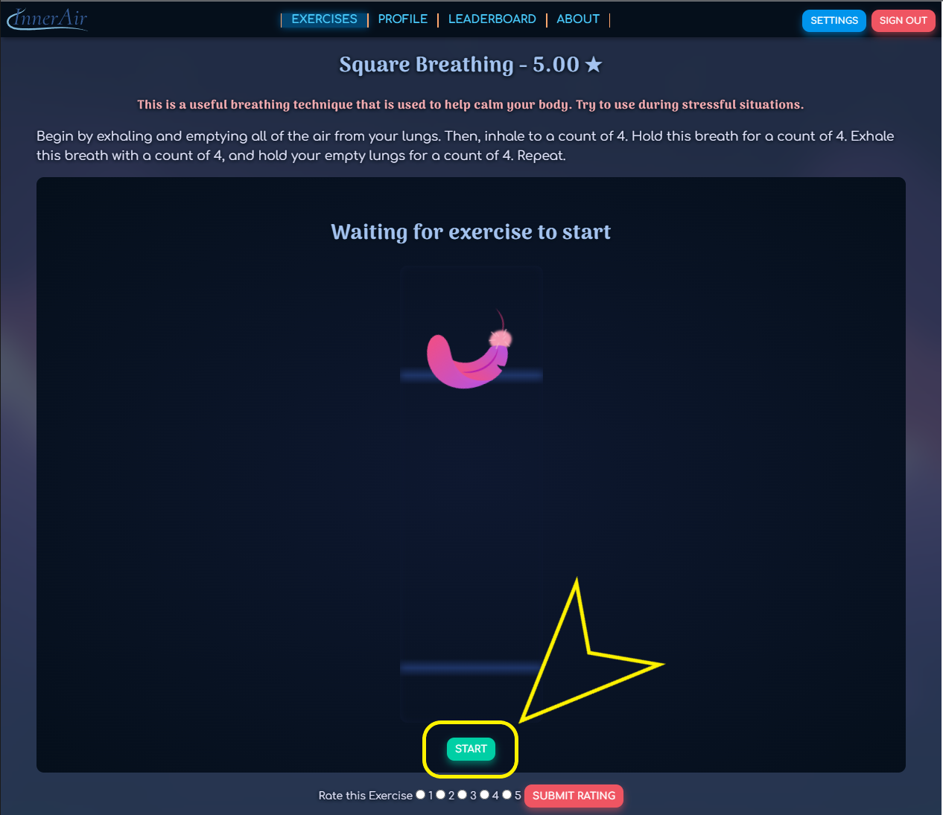

When the exercise ends, “Exercise Done!” will be displayed above the feather

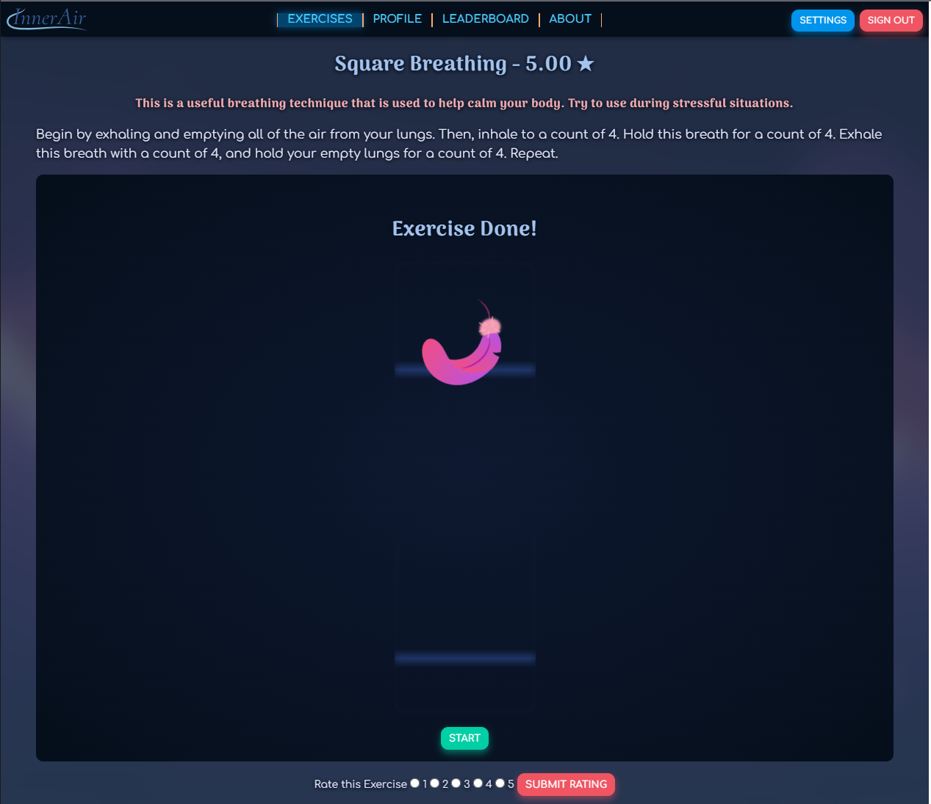

* 1. Rating an exercise

At the bottom of the page for each exercise, you may submit a rating

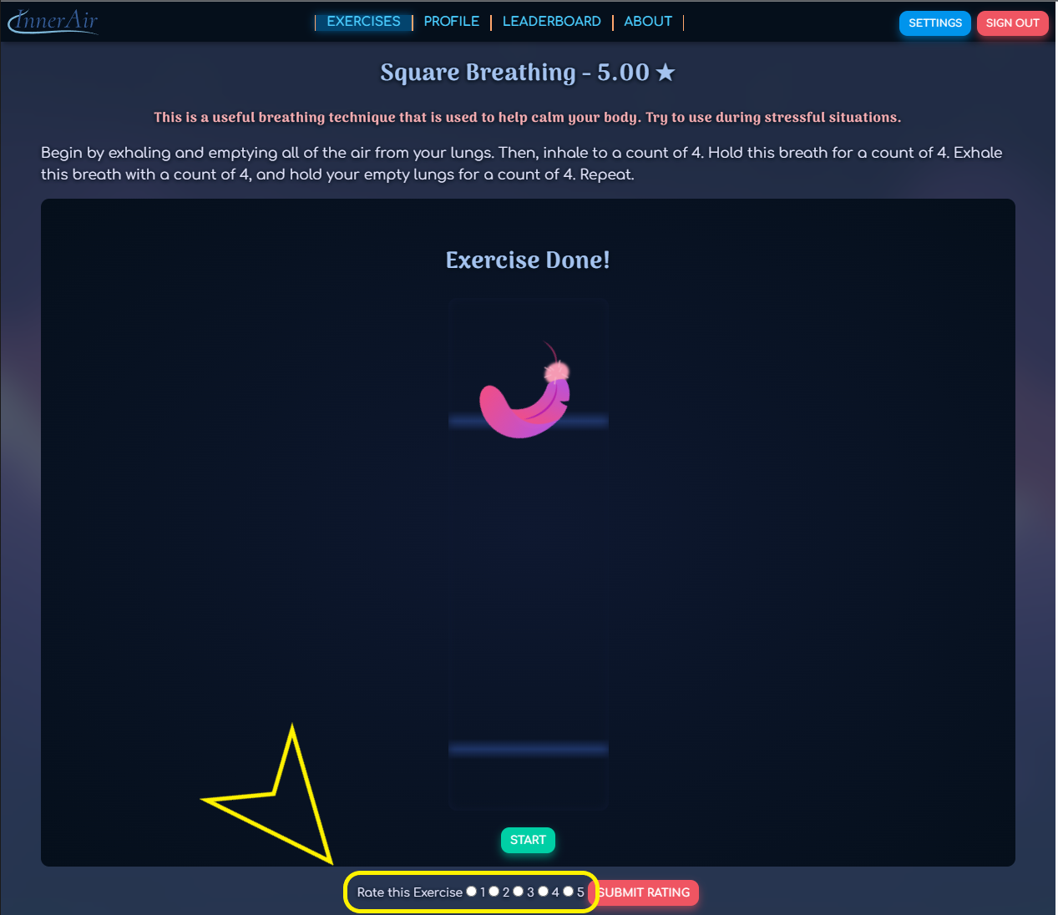

Select a number and click **SUBMIT RATING**

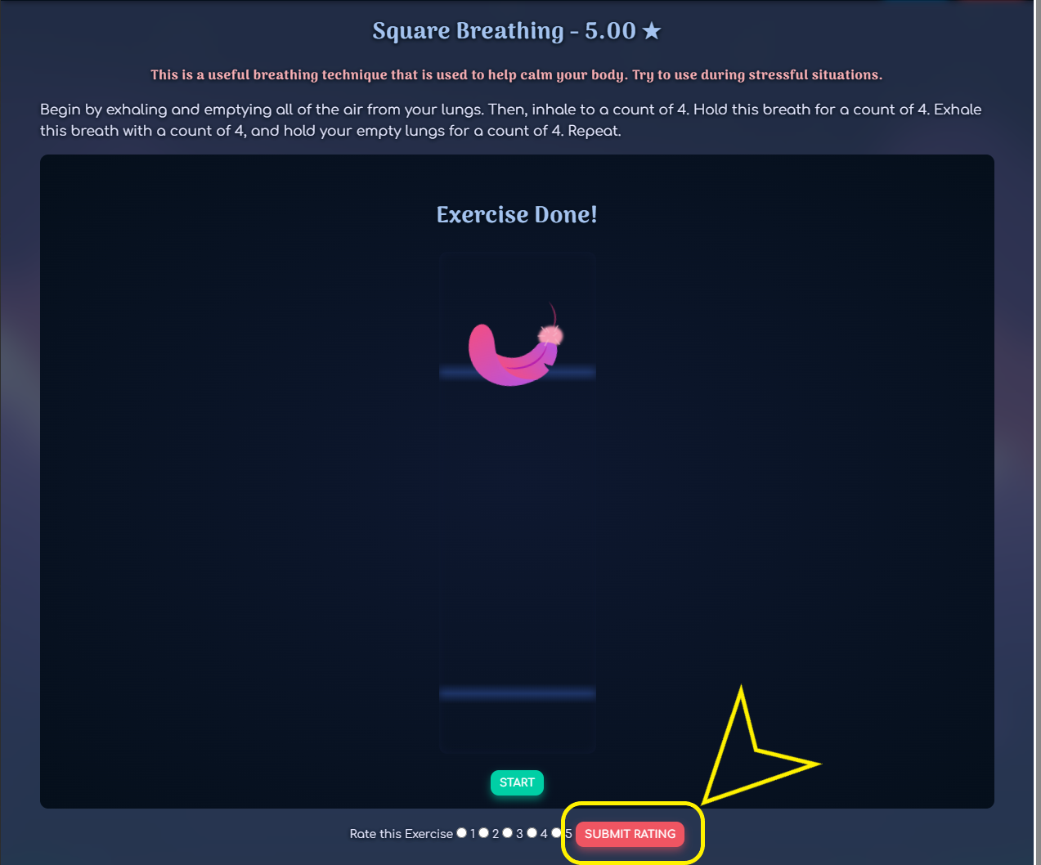

* 1. Saving an exercise to favorites

Click the **EXERCISES** tab at the top of the page



Click the **green heart button** next to the exercise name to save the exercise to favorites

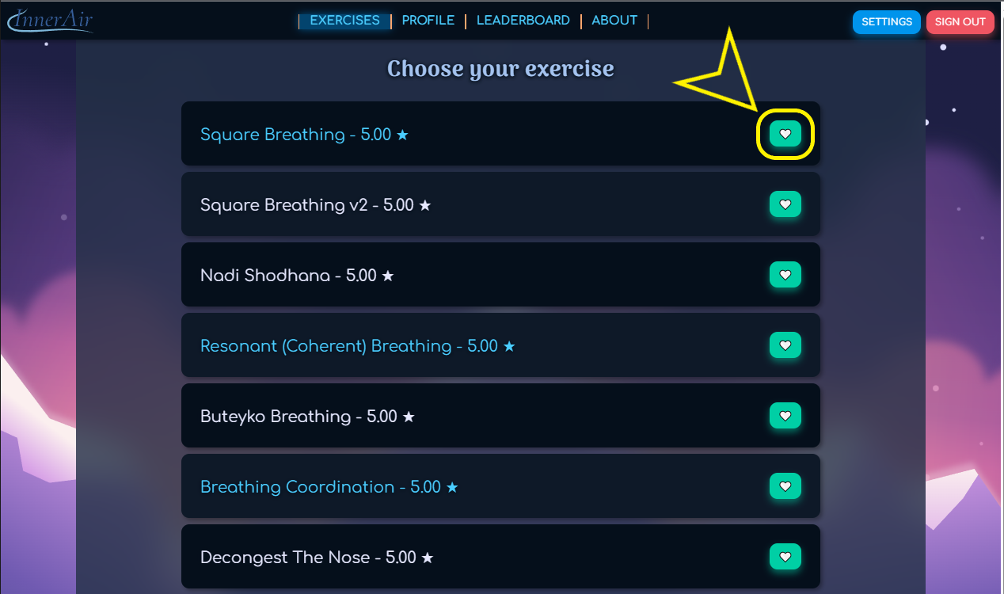

After clicking the heart button your favorites will be updated on your profile page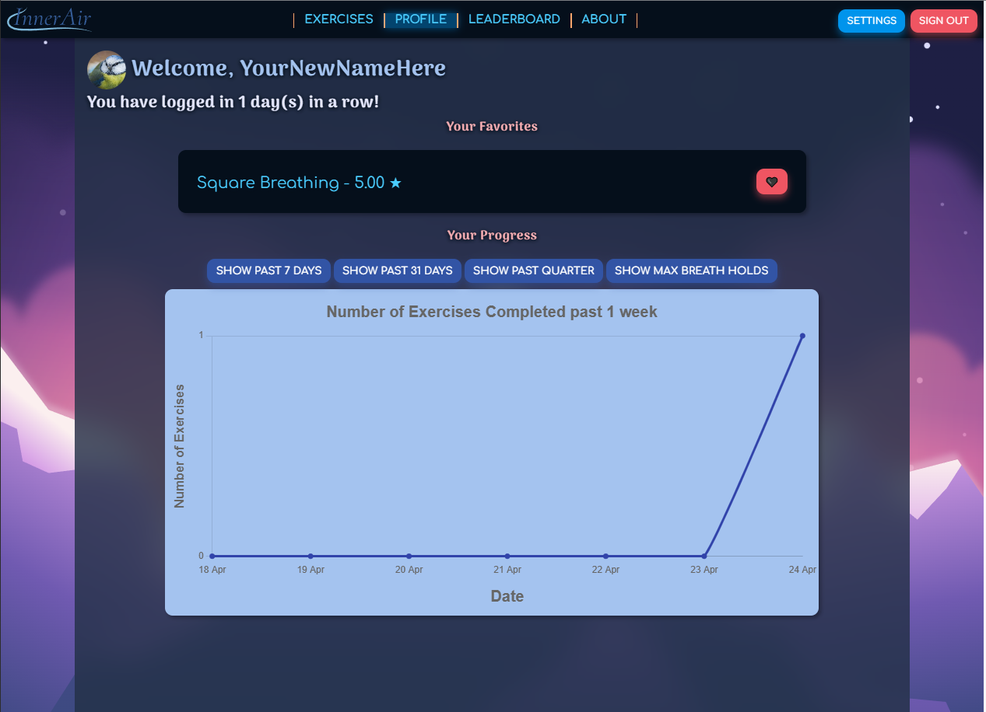

Click the **red heart button** located on your profile page next to the exercise name to remove the exercise from favorites.

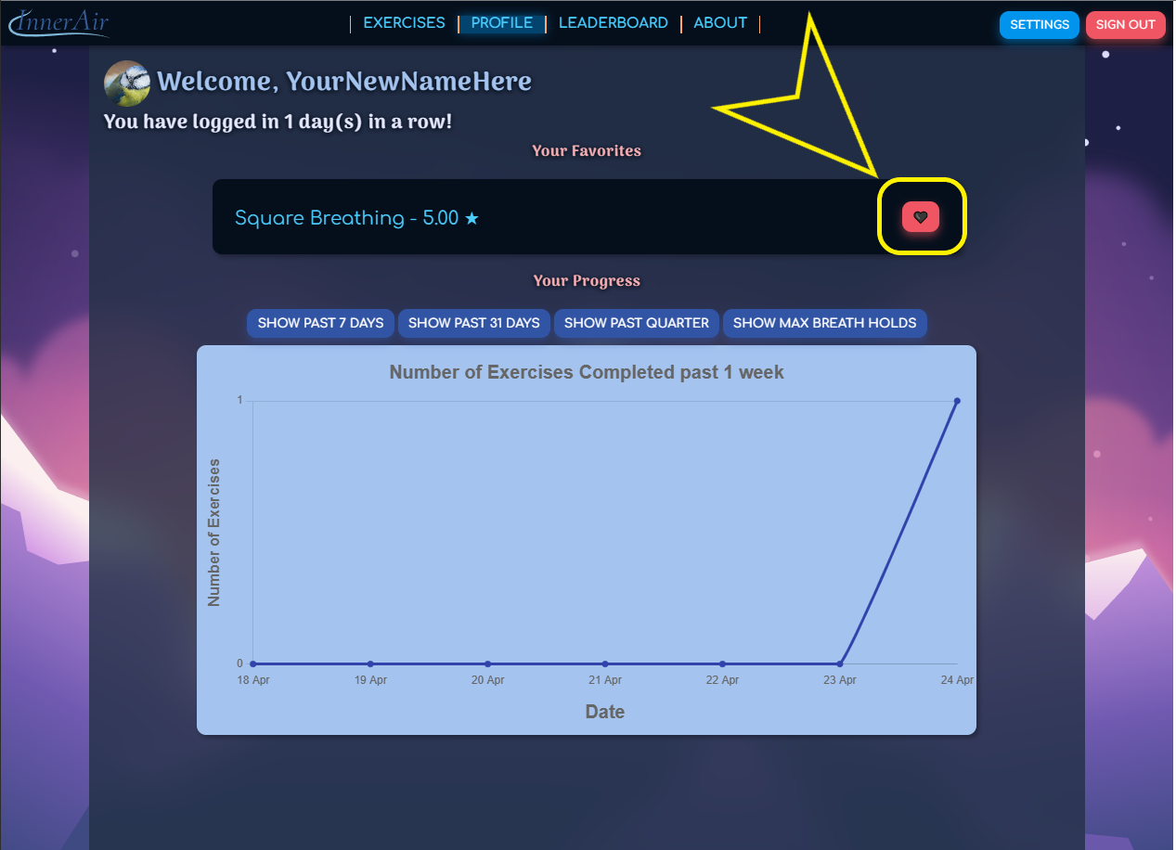

* 1. Viewing your progress

Click the **PROFILE** tab at the top of the page

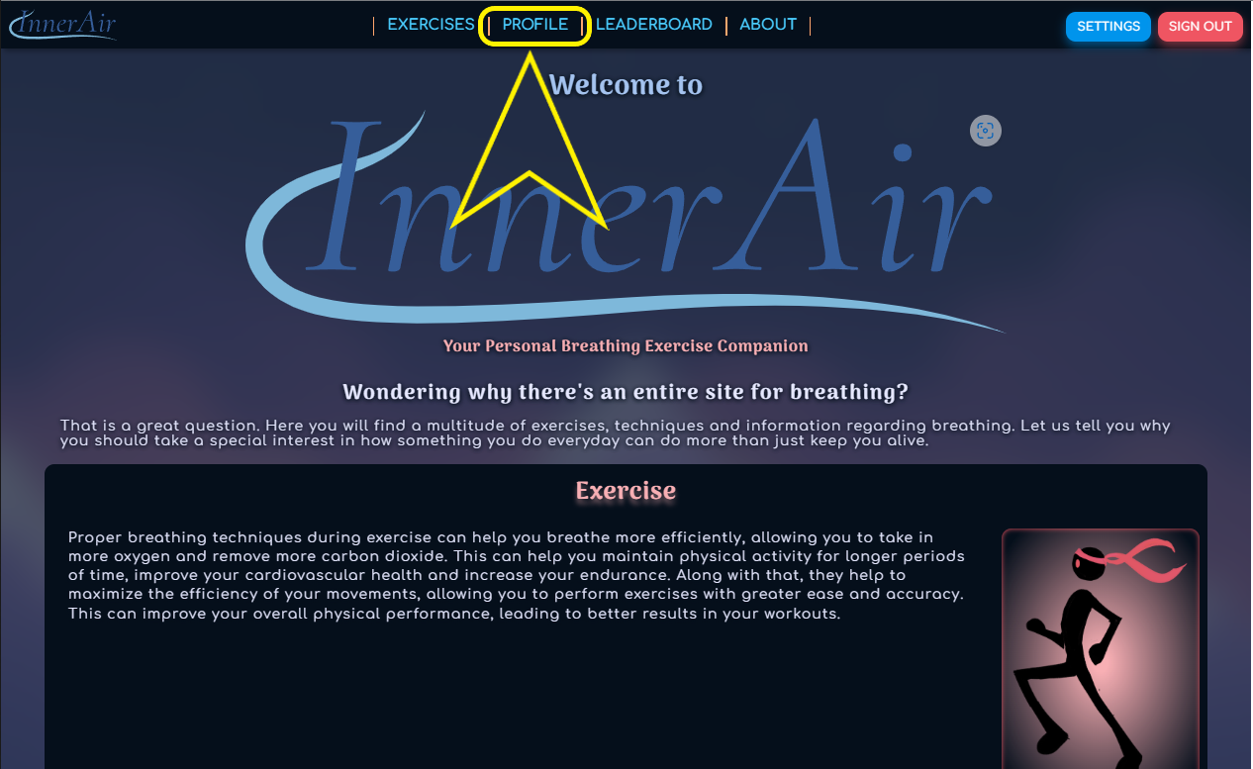

Click the buttons above the graph to view different graphs

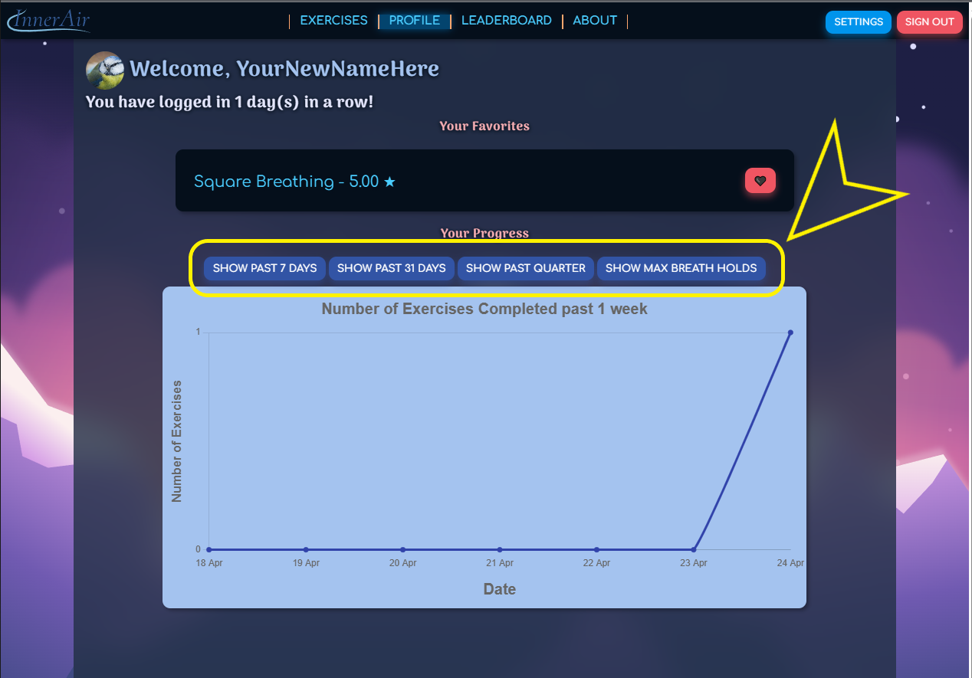

* 1. Comparing your progress to others users’

Click the **LEADERBOARD** tab at the top of the page to view user statistics

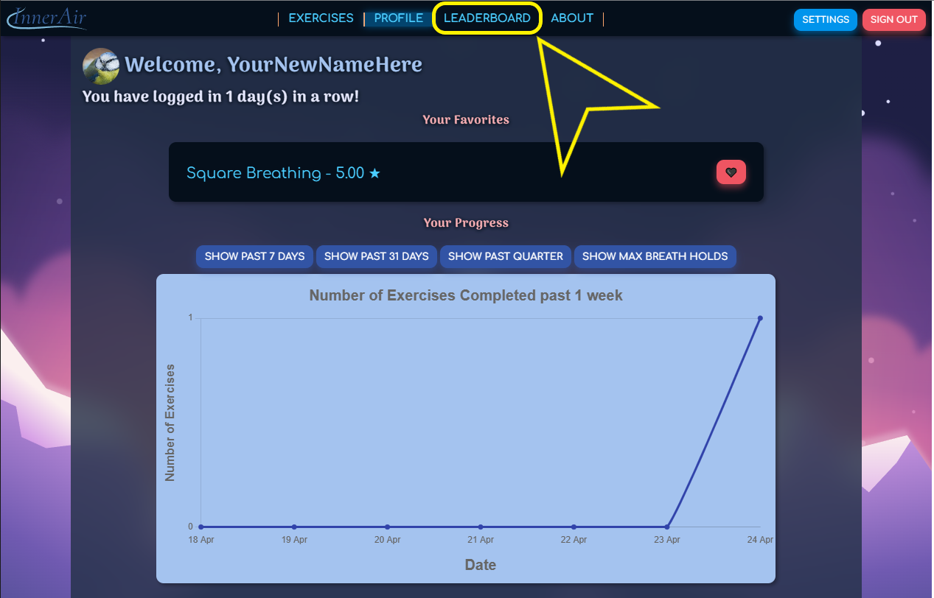

* 1. Signing out

Click the **SIGN OUT** button in the upper right-hand corner

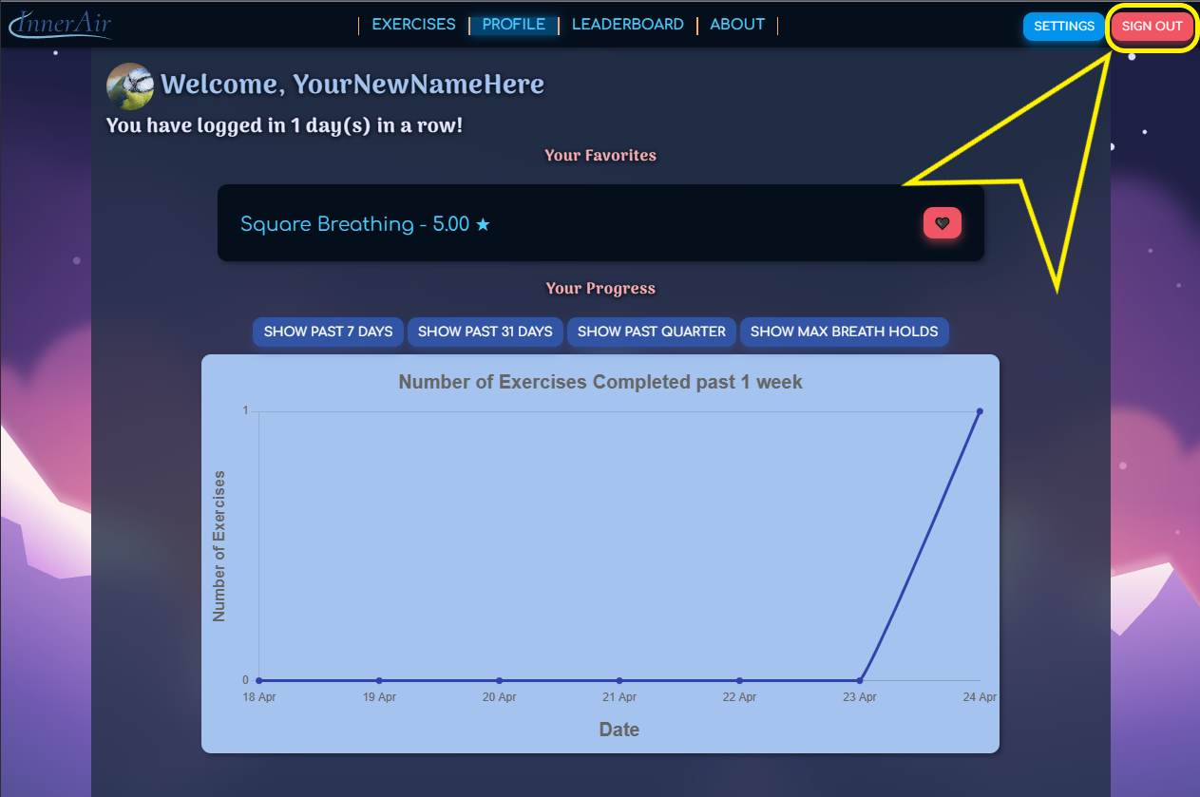

1. Quick Start Guide

Import Docker container and run it on a server.

Alternatively, the application can be used –as is – and can be “installed” and “updated” via git pulls to the production branch for this application. The setup will be completed by following the steps in the readme.md file included in GitHub.

You will need a .env file with the following values.

##################### # BASE CONFIG # #####################  
DB_NAME= <DB Name here>  
APP_SETTINGS=inner_air.config.DevelopmentConfig  
APP_TESTING_SETTINGS=inner_air.config.TestingConfig

# Key for database access  
SECRET_KEY=7c46fc1eb630e3a945fddc9ee1f73978e41f976b84184e1bb30d53cf5d10101624a8c45b55a0a635adcba38a529fecbdd960e1c5fdf3ba4a5ed339d5a3735459  
  
##################### # PROFILE PIC # #####################  
HOST=<url>  
USR=<your_username>  
PASSWD=<your_password>  
  
UPLOAD_FOLDER=inner_air/user/static/img/profile_pics/  
  
##################### # MAIL SETTINGS # #####################  
  
SECURITY_PASSWORD_SALT= <PW Salt here>  
APP_MAIL_DEFAULT_SENDER= < Email sender >  
APP_MAIL_USERNAME= < Email address to log in with >  
APP_MAIL_PASSWORD= < Email password >

Once you have a DNS or IP you can navigate to Inner Air via this link: http://<FQDN or IP>:5000/

New users must create an account to be able to use all the site’s features.

Existing users must sign in to continue their progress.

1. FAQs

* What is Inner Air?
  + Inner Air is a website that offers a variety of guided controlled breathing exercises that can be done from almost anywhere.
* Who is Inner Air for?
  + Inner Air is for anyone who would like to practice controlled breathing. The breathing exercises can help improve physical abilities, meditation, and relaxation techniques.
* Am I required to create an account to use Inner Air?
  + Yes. Inner Air tracks your progress and allows you to compare your progress with that of other users. You must create an account to access all of the site’s features.
* Is Inner Air free?
  + Yes! Inner Air is free to use.
* Can I change my name after creating an account?
  + Yes. You can change your name, email, and password from the **PROFILE** tab.
* Can I use Inner Air with a medical condition?
  + Inner Air offers controlled breathing exercises that can be done from almost anywhere. Consult with your doctor before trying any breathing exercises.